Public Health Passenger Locator Form
Use your camera or QR code app on a smart phone and scan:

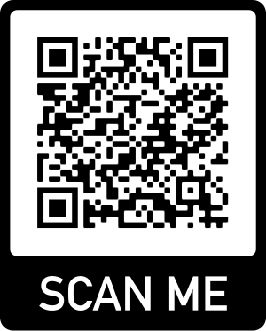

Or visit the website:
https://visas-immigration.service.gov.uk/public-health-passenger-locator-form?_ga=2.23270842.121727849.1591544764-1171444009.1591544764

